RNS Number:
Talisman Metals PLC
2 September 2026



Talisman Metals PLC

("Talisman" or the "Company")

Tirzzit Drill Campaign Starts

Talisman Metals PLC (“Talisman” or the “Company”) announces that the drilling campaign at Tirzzit has commenced (see press release of 18 August 2026). The drill programme is presently scheduled to drill 33 holes for a total of 2,770m, with additional capacity to drill targets of opportunity throughout the campaign. Planned hole depth ranges anywhere from 40m to 140m and work will be undertaken along the entire 4km strike (see press release of 23 July 2026). The Company will provide updates as drilling progresses.

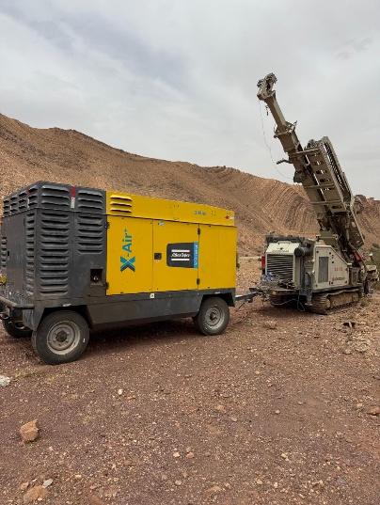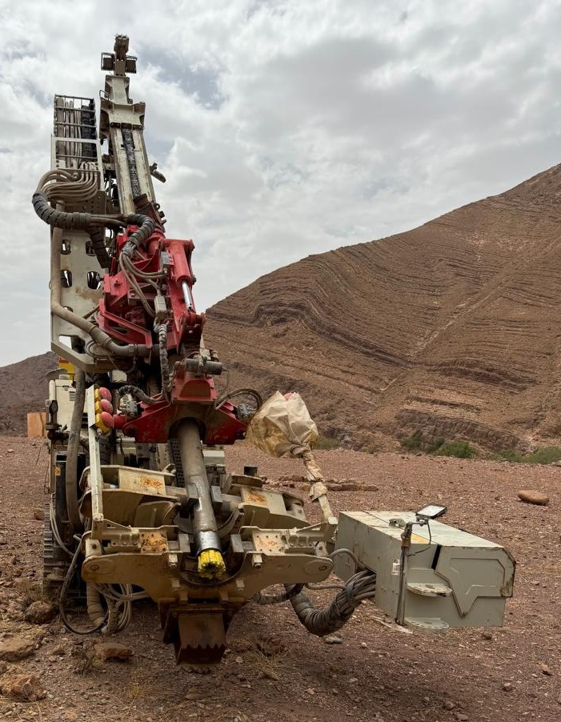
Pictures 1 & 2: RC drill rig and compressor at site

About the Tirzzit Project
The Tirzzit Project is a sediment-hosted stratiform Cu-Ag system, located 225km east of the city of Agadir, Morocco. The acquisition transaction of the Project was announced February 16, 2026 (see press release) from a wholly owned subsidiary of Aya Silver & Gold Inc. (TSX: AYA; OTCQX: AYASF) (“Aya”), the Company’s 4.7% shareholder. The Tirzzit Project consists of two mining licenses covering a surface area of 16.5km². Historic drilling results, as reported by Moroccan Government agency Bureau of Research and Mining Participations (BRPM) between 1972 and 1976 (“BRPM Reports”), include drill intersections of 3.16% Cu over 2.5m and 0.60% Cu over 11.4m. Presently the Company is reviewing the extensive BRPM Reports and past collected geophysical data for exploration planning slated to commence in 3Q2026. Talisman continues to process with Aya the formal transfer of the Tirzzit licences on the back of the sale agreement announced February 16, 2026.

End

For further information:

Talisman Metals PLC
Tim McCutcheon (Chief Executive Officer and Director)
Tel +353 (0) 1 525 6710
contactus@talismanmetalsplc.com

Beaumont Cornish Limited (Nominated Adviser)
James Biddle / Roland Cornish
Tel: +44 (0) 207 628 3396

CMC Markets UK Plc (Broker)
Thomas Smith / Thomas Curran
Tel: +44 (0) 20 3003 8255

BlytheRay (Financial PR)
Megan Ray / Said Izagaren
Tel: +44 (0) 20 7138 3204
talismanmetals@blytheray.com

Technical Glossary

Ag | Silver
Cu | Copper
Reverse Circulation (“RC”) drilling | A fast, cost-effective method for collecting rock samples. Compressed air is pumped down the annulus (the space between inner and outer drilling tubes), while pulverized rock cuttings are forced back up through the inner tube to the surface. This “reverse” flow is what gives the method its name and ensures dry, uncontaminated samples suitable for analysis.

This announcement contains inside information for the purposes of Article 7 of the Market Abuse Regulations (EU) No. 596/2014, as it forms part of UK Domestic Law by virtue of the European Union (Withdrawal) Act 2018. Upon publication of this announcement, this inside information is now considered to be in the public domain.

Nominated Adviser Statement
Beaumont Cornish Limited ("Beaumont Cornish"), is the Company's Nominated Adviser and is authorised and regulated in the United Kingdom by the Financial Conduct Authority. Beaumont Cornish's responsibilities as the Company's Nominated Adviser, including a responsibility to advise and guide the Company on its responsibilities under the AIM Rules for Companies and AIM Rules for Nominated Advisers, are owed solely to the London Stock Exchange. Beaumont Cornish is not acting for and will not be responsible to any other person for providing the protections afforded to customers of Beaumont Cornish nor for advising them in relation to the transaction and arrangements described in the announcement or any matter referred to in it.

