RNS Number:
Talisman Metals PLC
16 February 2026



Talisman Metals PLC

("Talisman" or the "Company")

Acquisition of the Tirzzit Copper Project

Dublin, Ireland, 16 February 2026 – Talisman announces it has signed an agreement to acquire the Tirzzit Copper Project (“Tirzzit” or the “Project”) from a wholly-owned subsidiary of Aya Silver & Gold Inc. (TSX: AYA; OTCQX: AYASF) (“Aya”), the Company’s 4.7% shareholder. The Project consists of two mining licenses (“ML’s”) covering a surface area of 16.5km² within the Agadir regional mining department, Kingdom of Morocco (“Morocco”), and located 225km east of the city of Agadir, Morocco. Tirzzit is located 85km north-east of the Company’s existing Tizert Project.

Talisman’s CEO, Tim McCutcheon, said: “The acquisition of Tirzzit builds out our project pipeline with a more advanced target, which has great upside potential based on the results of historical exploration work. Talisman’s ability to acquire this project on very favourable terms is a testament to the corporate development work the team has done, and its collaboration with Aya to take on earlier-stage copper projects that are a better fit for Talisman than for our multi-billion-dollar market cap peer. Over the coming months, we will take the existing data to determine our development plan and update shareholders accordingly.”

GEOLOGY

The Tirzzit deposit is classified as a sediment-hosted stratiform Cu-Ag system (SHSC) developed within the Neoproterozoic-age Adoudou Formation that is the host for multiple similar copper-silver deposits throughout the region, including the Tizert Copper-Silver Mine with an estimated mineral resource of 130M tonnes which is presently entering commercial production. Talisman has several licenses in the Tizert area, which the Company labels “Tizert Project”. The area’s copper-rich mineralisation occurs in specific sedimentary units (carbon-rich siltstone and the base of dolomitic limestone) that can be readily traced where the shallow-dipping units outcrop at surface.

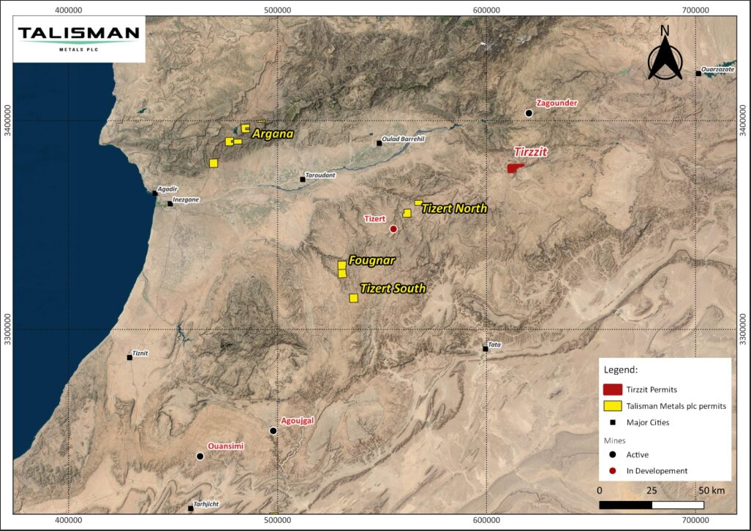
Figure 1: Project Location Map

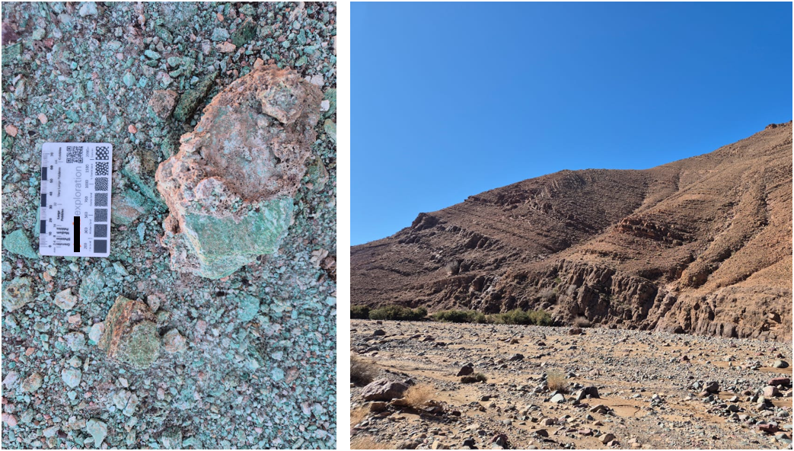
Figure 2: Malachite (copper-carbonate) mineralisation (left) typical of that observed in the outcropping sedimentary host units (right).
HISTORICAL EXPLORATION

A summary of past exploration activities describes extensive work undertaken by Moroccan Government agency BRPM between 1972 and 1976 (“BRPM Reports”), including channel sampling in pits (70m) and trenches (225m) and 3 exploration adits and raise (1,679m), mapping and grab-sampling of outcropping rocks, and 4,978m of drilling (35 drill holes).

Key drill intersections included 3.16% Cu over 2.5m at 224m downhole (TT28), 0.60% Cu over 11.4m from 72.8m (TT6), and 2.08% Cu and 36 g/t Ag over 2.25m from 319.5m (TT32) with observations of mainly Malachite, and on occasions Bornite and Chalcocite. Grab samples of outcropping zones of mineralisation included 6.00% Cu from malachite-rich limestone and 4.60% Cu from chalcocite rich limestone and up to 2.56% Cu in siltstones (data from BPRM Reports).

Recent work undertaken and reported during 2019-2025 incorporated ASTER remote sensing to map out alteration, airborne geophysical surveys (SkyTEM, VLF and Aero Magnetics), stream sediment sampling (43 samples), and detailed mapping with grab sampling (117 samples), resulting in the delineation of structural and stratigraphic controls to the mineralisation and confirmed positive copper contents of outcropping sedimentary units. Additionally, a Talisman site visit in February 2026 confirmed mineralised zones exposed over approximately 3km up to 6 meters of apparent thickness in the centre of the ML package.

Important Disclaimer: the Company has not yet undertaken any work to verify the above reported results in accordance with JORC (2012) and therefore these results should be treated with caution (note detailed Disclaimer below).

TRANSACTION

Talisman’s wholly owned subsidiary, Horizons Mines SARL has entered into an agreement, conditional only on registration of the licence and the entering into an SPA on the same terms, to acquire the two ML’s. To complete the acquisition of Tirzzit, Talisman will pay to Aya’s wholly-owned subsidiary 200,000 Moroccan Dirhams (approximately £16,000). Concurrently, Talisman agreed to enter into a binding agreement pursuant to which it will assign a non-core license within the region of Boumadine, Morocco, to Aya (via its wholly-owned subsidiary). The MLs expire on 29/07/2028 and 16/11/2028 and are renewable under Moroccan regulations. Upon completion of the acquisition, the MLs will be reregistered to Talisman’s wholly-owned Moroccan subsidiary.

Following the transaction, Talisman’s core Exploration Permits and Mining Licenses will be as follows:

Core Exploration Permits

Asset | Holder | Status | Permit No.
Argana Project | Horizon Mines | Exploration | 3942221
Argana Project | Horizon Mines | Exploration | 3942215
Argana Project | Horizon Mines | Exploration | 3942216
Argana Project | Horizon Mines | Exploration | 3942217
Argana Project | Horizon Mines | Exploration | 3942220
Tizert Project | Horizon Mines | Exploration | 3942226
Tizert Project | Horizon Mines | Exploration | 3942218
Tizert Project | Horizon Mines | Exploration | 3942219
Tizert Project | Horizon Mines | Exploration | 3942418
Tizert Project | Horizon Mines | Exploration | 3942419
Tirzzit Project | Horizon Mines | Mining | 393478
Tirzzit Project | Horizon Mines | Mining | 393507

End

For further information:

Talisman Metals PLC
Tim McCutcheon (Chief Executive Officer and Director)
Tel +353 (0) 1 525 6710
contactus@talismanmetalsplc.com

Beaumont Cornish Limited (Nominated Adviser)
James Biddle / Roland Cornish
Tel: +44 (0) 207 628 3396

CMC Markets UK Plc (Broker)
Thomas Smith / Thomas Curran
Tel: +44 (0) 20 3003 8255
BlytheRay (Financial PR)
Megan Ray / Said Izagaren
Tel: +44 (0) 20 7138 3204
talismanmetals@blytheray.com

Qualified Person

The technical disclosure in this news release has been approved by Fabien Linares, MSc, MAusIMM, a Qualified Person as defined in JORC 2012. The scientific and technical information summarized in this disclosure and related to historic exploration was reviewed by Mr. Linares and he has visited the Project area. Mr. Linares is Head Geologist of Talisman Metals PLC and has sufficient experience that is relevant to the commodity, style of mineralisation or type of deposit under consideration and activity which he is undertaking to qualify as a Competent Person under the JORC code (2012 Edition).

JORC Code (2012) – Historical Exploration Results Disclaimer

The information in this announcement that relates to historical reported exploration results is based on, and fairly represents, information and supporting documentation prepared by previous operators and/or extracted from historical reports.

The historical exploration results referred to in this announcement were reported prior to the introduction of the JORC Code (2012) and have not been reported in accordance with the JORC Code (2012).

A Competent Person has not done sufficient work to disclose the historical exploration results in accordance with the JORC Code (2012). It is possible that following further evaluation and/or exploration work, the accuracy and reliability of the historical exploration results may not be confirmed.

The Company has not independently verified the historical exploration results, and no assurance can be given that future exploration work will result in the confirmation or upgrade of the historical results to JORC Code (2012) compliant Mineral Resources or Ore Reserves.

The Company considers the historical exploration results to be relevant as they provide an indication of the potential of the project. However, the information should not be relied upon as a representation of the current mineral resource or exploration potential.

Nominated Adviser Statement

Beaumont Cornish Limited ("Beaumont Cornish"), is the Company's Nominated Adviser and is authorised and regulated in the United Kingdom by the Financial Conduct Authority. Beaumont Cornish's responsibilities as the Company's Nominated Adviser, including a responsibility to advise and guide the Company on its responsibilities under the AIM Rules for Companies and AIM Rules for Nominated Advisers, are owed solely to the London Stock Exchange. Beaumont Cornish is not acting for and will not be responsible to any other person for providing the protections afforded to customers of Beaumont Cornish nor for advising them in relation to the transaction and arrangements described in the announcement or any matter referred to in it.

Technical Glossary

A small number of terms used in this notice are defined below to ensure clarity.

Sediment-hosted stratiform copper (SHSC)
Copper mineralisation confined to a single sedimentary layer or a small number of closely associated sedimentary layers. The copper minerals in near-surface oxidized material usually comprise mixed copper oxides and copper carbonates, the latter usually dominated by the copper carbonate malachite. Below the depth of oxidation (weathering) the copper minerals comprise mostly copper sulfides. Silver minerals are a relatively common component of this kind of mineral deposit.

Percentage (%)
Metal contents reported here as percentages in mass.

